**MOVIE DATABASE MANAGEMENT SYSTEM**

**Introduction to Movie Database Management System**

A Movie Database Management System (MDBMS) is a comprehensive software solution designed to organize, manage, and analyze data related to the film industry. This includes information about movies, directors, actors, genres, and more. In this context, we'll explore the schema for a movie database comprising tables for directors, movie types (genres), movies, and actors.

**Various Entities**

**Director:**

* **Director_Id**
* **Director_Name**
* **Hit_Count**
* **Floop_Count**
* **Average_Count**

**MovieType:**

* **Genre_Id**
* **Genre**

**Movie:**

* **Movie_Id**
* **Movie_Name**
* **Year_Release**
* **Status**
* **Triler**
* **Rating**
* **Genre_Id**
* **Director_Id**

**Actor:**

* **Actor_Id**
* **Actor_Name**
* **Movie_Id**
* **Role**

**User:**

* **User_Id**
* **User_Name**
* **Phone_Number**
* **Email_Id**

**Login:**

* **Login_Id**
* **User_Name**
* **Password**

**ER Diagram:**

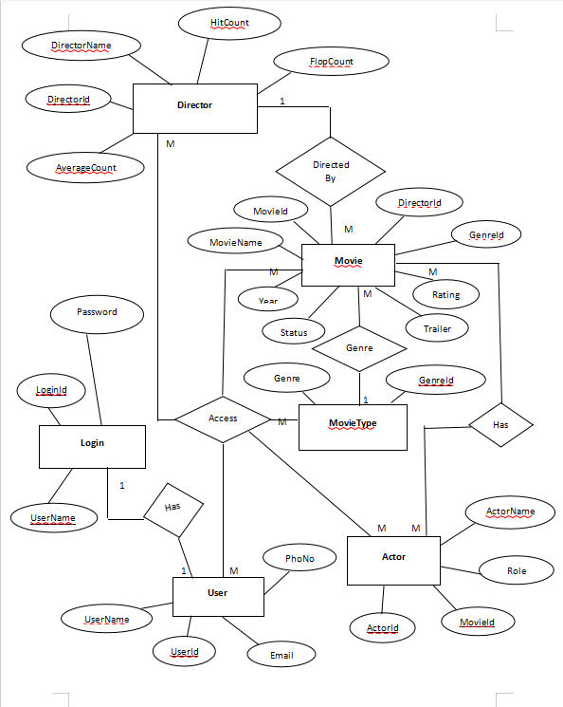

**Class Diagram:**

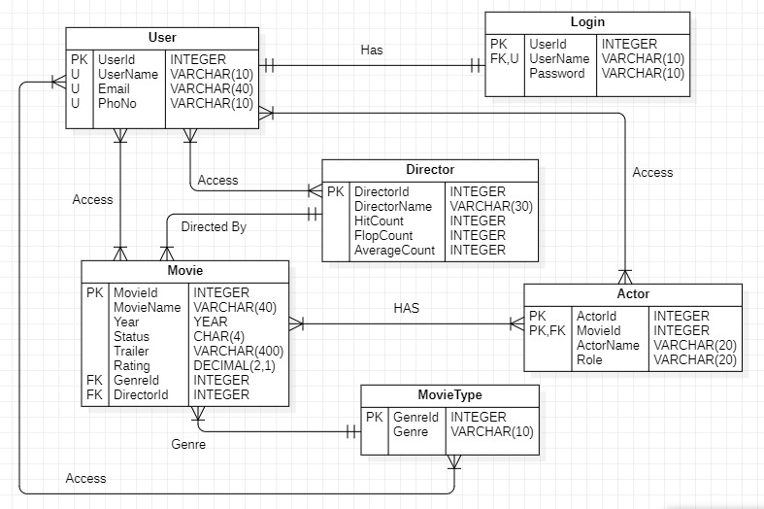

**Conclusion**

In conclusion, a well-designed movie database management system facilitates the efficient organization, retrieval, and analysis of movie-related data. By leveraging tables such as Director, MovieType, Movie, and Actor, stakeholders in the film industry can effectively manage directorial performance, categorize movies by genre, store detailed movie information, and track actor roles. This structured approach enhances decision-making, fosters collaboration, and improves the overall management of movie data.